Big Mountain Resort is not charging what it is worth. I have found solutions to fix this and get the resort the money that it deserves. This includes strategies to cut costs while at the same time increasing ticket prices. To do this, I observed data obtained from Alesha Eisen, the database manager. While going through this data, I found that certain values were missing. Depending on what the value point was to, that segment would be deleted and ignored, or I would use an average based on the other resorts in the area and other values given. Segments that were dropped were resorts that had missing information on their ticket prices. I also used some of the information to calculate ratios to find comparisons and added those into the datasheet. Those ratios can be found in this data sheet along with the other information that was already given in the data. This data table will be shown on the next page.

Using the information gathered and the random forest regressor, I have discovered that visitors value fast quads, runs, snow making(acres), and vertical drop the most in resorts.

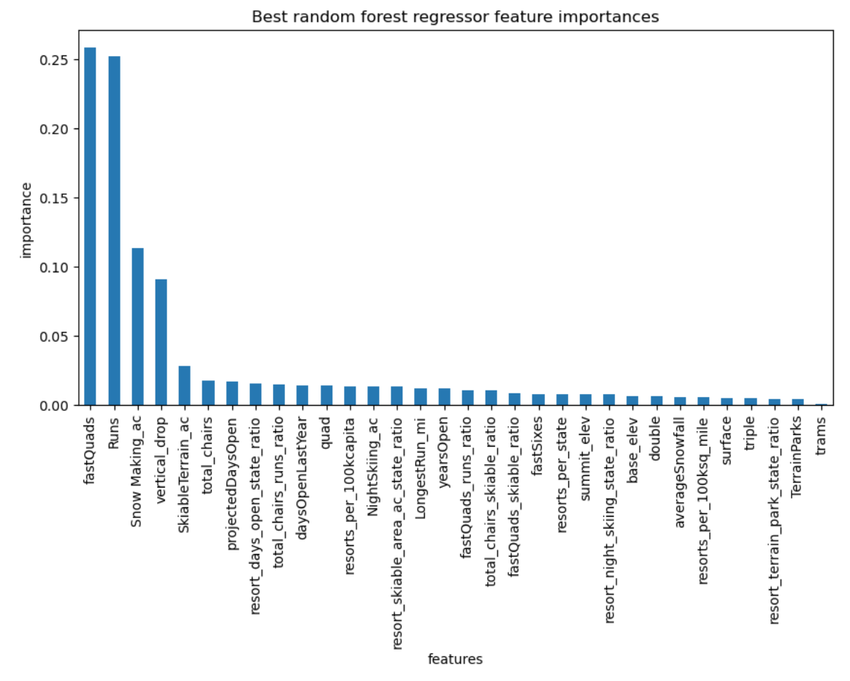

Therefore, these should be the features of the resort that should be highlighted or changed to support an increase in ticket price. Changes that would support the price of tickets going up, would be to increase the vertical drop and adding another chairlift for that specific run, preferably a fast quad. This will support the ticket price increasing from $81 to roughly $95. With an estimated number of 350,000 people visiting per season with an average of 5 day tickets per person, the total amount made would come out to $17,322,717.

Another change to take into consideration is closing down the least used runs, up to 5. This will reduce the cost of operating the chair lifts connected to those runs and maintaining that part of the mountain. This will lower the cost per ticket, however only ever so slightly. The reason why the resort can close up to five is because 3-5 lifts closed will make the same difference in a drop in ticket prices.

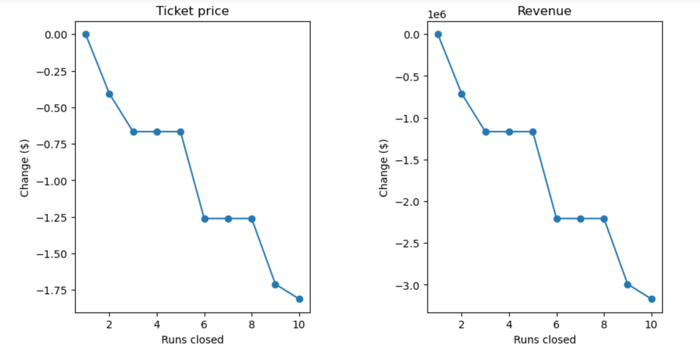

These scenarios will be effective options in reducing operating costs while at the same time support an increase in the price of a ticket. Big Mountain excels in a number of other areas already, so this would only solidify the increase in ticket price.

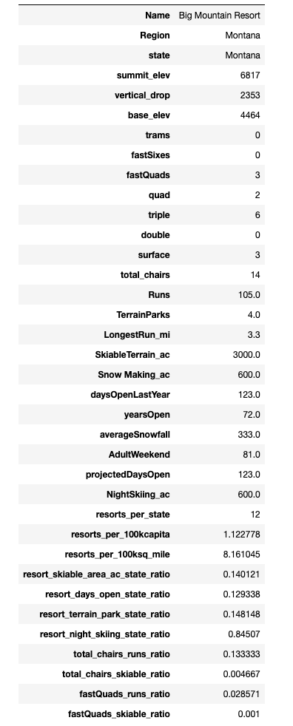

Currently, the price of an adult weekend pass to Big Mountain is $81. My modelling suggests that the ticket price could be increased to roughly $95.87 and with a mean absolut error of $10.39, there is still room for an increase in price. Some things business leadership could change are permanantly closing down up to 6 of the least used runs because this does not impact any other resort facilities while reducing the cost of operation. Another is increasing the vertical drop by 150 ft by adding a new chair lift at a lower point to bring visitors back up and/or creating 2 more acres of snow coverage. Closing down a few runs will reduce the cost of operations, but close too many and it does not support an increase in ticket price. The second scenario however, supports an increase of ticket price of roughly $8 and almost $10 with the addition of two acres of snow coverage. With visitors buying 5 day passes, the addition of this new chair could generate $15065471 and $17322717 in revenue respectively. A combination of both of these, would reduce operating costs while also support an increase in ticket price. Something like closing 2-3 runs would not effect the price in tickets, and the operating cost of running the chairs for those runs could be diverted into the new chair.